

CSA0501-DATABASE MANAGEMENT SYSTEMS

LAB EXPERIMENTS DATE: 29/07/2026

EXPERIMENT 17– HIGH LEVEL PROGRAMMING EXTENSIONS -Function s

AIM:
To implement user-defined functions in MySQL using the milka_dairy table.
procedure
Create a stored procedure using the CREATE PROCEDURE statement.
Give the procedure name as GetAllMilkRecords.
Use the DELIMITER command to change the default delimiter.
Use the SELECT statement to retrieve all records from the milka_dairy table.
Change the delimiter back to ;.
Execute the procedure using the CALL statement.

Problem-1
Create a function GetCustomerLevel() that returns the customer level based on the amount in the milka_dairy table.
The customer level is determined as follows:
- If amount > 1000, customer level = PLATINUM
- If amount >= 600 AND amount <= 1000, customer level = GOLD
- If amount < 600, customer level = SILVER

Problem 2

Create a function that returns the total amount for a given customer's name from the milka_dairy table.

Program 3

Create a function that returns the total liters supplied by a particular customer.

PROGRAM -1:

DELIMITER //

CREATE FUNCTION GetCustomerLevel(p_amount INT)
RETURNS VARCHAR(20)
DETERMINISTIC
BEGIN
DECLARE customer_level VARCHAR(20);

IF p_amount > 1000 THEN
SET customer_level = 'HIGH';
ELSEIF p_amount >= 600 AND p_amount <= 1000 THEN
SET customer_level = 'MEDIUM';
ELSE
SET customer_level = 'LOW';
END IF;

RETURN customer_level;
END //

DELIMITER ;
SELECT name, amount, GetCustomerLevel(amount) AS customer_level
FROM milka_dairy;

OUTPUT:

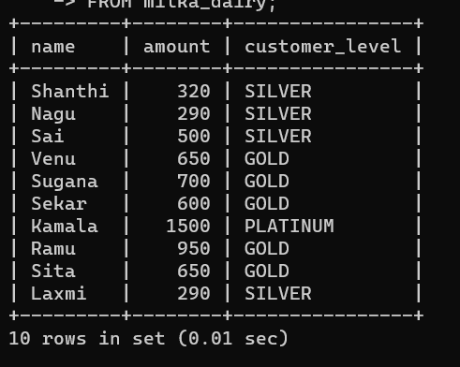

PROGRAMM -2

DELIMITER //

CREATE FUNCTION GetCustomerAmount(p_name VARCHAR(20))
RETURNS INT
DETERMINISTIC
BEGIN
DECLARE v_amount INT;

SELECT amount
INTO v_amount
FROM milka_dairy
WHERE name = p_name;

RETURN v_amount;
END //

DELIMITER ;
SELECT GetCustomerAmount('Kamala');

OUTPUT:

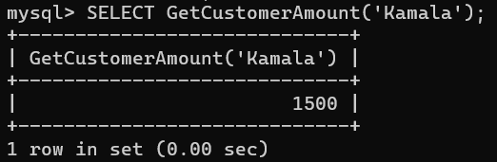

PROBLEM-3

DELIMITER //

CREATE FUNCTION GetMilkLiters(p_name VARCHAR(20))
RETURNS INT
DETERMINISTIC
BEGIN
DECLARE v_liters INT;

SELECT liters
INTO v_liters
FROM milka_dairy
WHERE name = p_name;

RETURN v_liters;
END //

DELIMITER ;
SELECT GetMilkLiters('Kamala');
OUTPUT:
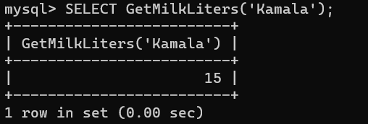
Result:Thus the Functions using program in MySQL executed successfully .

